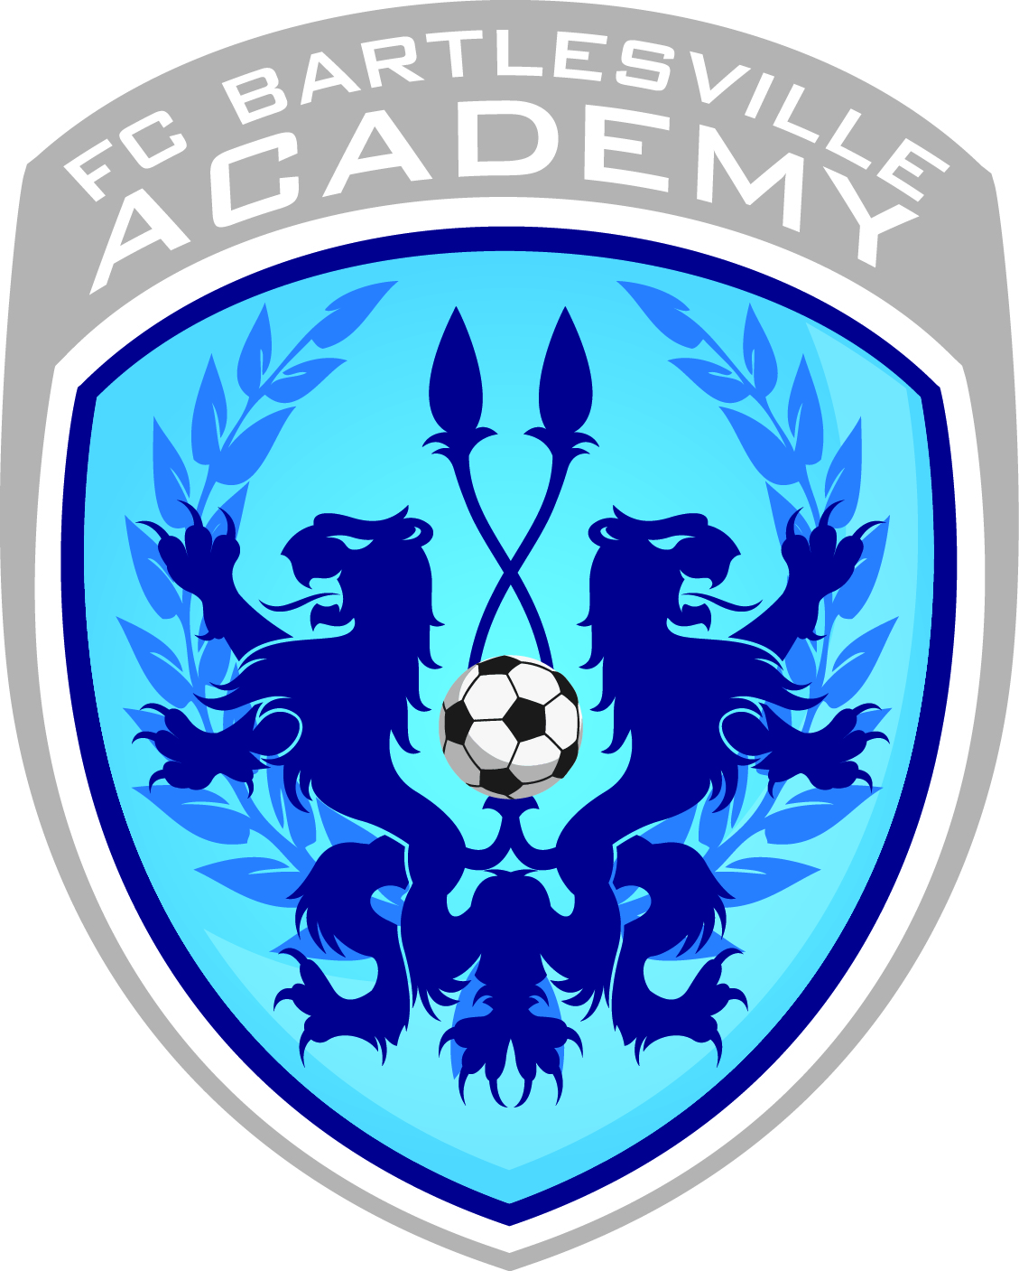

FC BARTLESVILLE ACADEMY PRESEASON CAMP

Date: July 21 – July 24
Ages: U8-U10
Time: 9:00am – 12:00pm
Location: Robinwood Park Soccer Complex
Cost: $80 per player

*Bring this form and payment with you on Monday, July 21st. Coaches will be at the fields by 8:30am for you to sign-up and drop off your player(s).
*All players need to wear their shin-guards and bring a ball.
*Most importantly, all players need to bring plenty of water!
*Make all checks payable to FCB

Camper Name: _________________________________

D.O.B ____/____/______

Parent/Guardian: _______________________________

Home #: _____________ Cell #:____________________

Emergency Contact: ________________ Phone: __________

Please circle: Male / Female

I/we authorize, when necessary for protecting the health and well-being of the above-named individual, permission for treatment at a competent and/or accredited facility. I/we further release The FC Bartlesville Coaches and Staff and the Washington County Soccer Club from any liability for damage and injury to the above-named individual and hereby accept full responsibility for all damages or injuries sustained as a result of participation in the FCB Academy Soccer Camp.

______________________________________________________________________________
PARENT OR GUARDIAN (S) SIGNATURE DATE

