TRANSPORTATION RELEASE FORM
2014

Sport: Boys Soccer Coach: Micah Lipscomb
** This form must be completed and returned to the Head Coach no later than two days prior to the athletic event.**
lipscombmb@bps-ok.org
I Click here to enter text. (parent/guardian) give my permission for my child Click here to enter text. (student) to ride home with the following parents from an athletic contest. I understand that as a parent/guardian of this student that this form releases the school from all responsibility for my child.
Please list the specific parents that your child can ride home with.
1) | Click here to enter text. | 11) | Click here to enter text. | 21) | Click here to enter text.
2) | Click here to enter text. | 12) | Click here to enter text. | 22) | Click here to enter text.
3) | Click here to enter text. | 13) | Click here to enter text. | 23) | Click here to enter text.
4) | Click here to enter text. | 14) | Click here to enter text. | 24) | Click here to enter text.
5) | Click here to enter text. | 15) | Click here to enter text. | 25) | Click here to enter text.
6) | Click here to enter text. | 16) | Click here to enter text. | 26) | Click here to enter text.
7) | Click here to enter text. | 17) | Click here to enter text. | 27) | Click here to enter text.
8) | Click here to enter text. | 18) | Click here to enter text. | 28) | Click here to enter text.
9) | Click here to enter text. | 19) | Click here to enter text. | 29) | Click here to enter text.
10) | Click here to enter text. | 20) | Click here to enter text. | 30) | Click here to enter text.
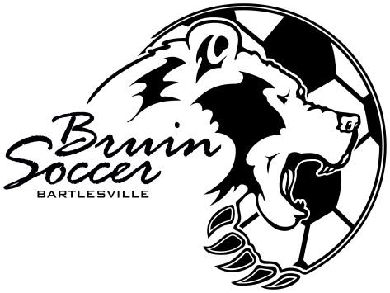

Click here to enter text. (electronic) Click here to enter a date.
Parent/Guardian Signature Date

